Project Design Phase
Solution Architecture
Date | 28 October 2026
Team ID | To Be Confirmed
Project Name | HotelPro – Hotel Management System
Maximum Marks | 4 Marks
Document Status | Draft v1.0 – prepared from the stated HotelPro requirements. No HotelPro source code has been provided or verified, so all features are marked Planned.

1. Solution Architecture
The solution architecture for HotelPro is planned to be robust, secure, user-friendly and scalable. It connects guests with available rooms, supports the hotel’s daily operations and gives managers and administrators the data and controls they need. The architecture focuses on responsive design, secure transactions, role-based access and reliable booking workflows.
- Seamless room search, booking and payment
- End-to-end stay lifecycle management (reservation → check-in → services → check-out → review)
- Scalable authentication and authorisation using JWT and roles
- Secure and trackable payment transactions
- Reliable notifications and auditable administrative actions

2. Solution Architecture Diagram
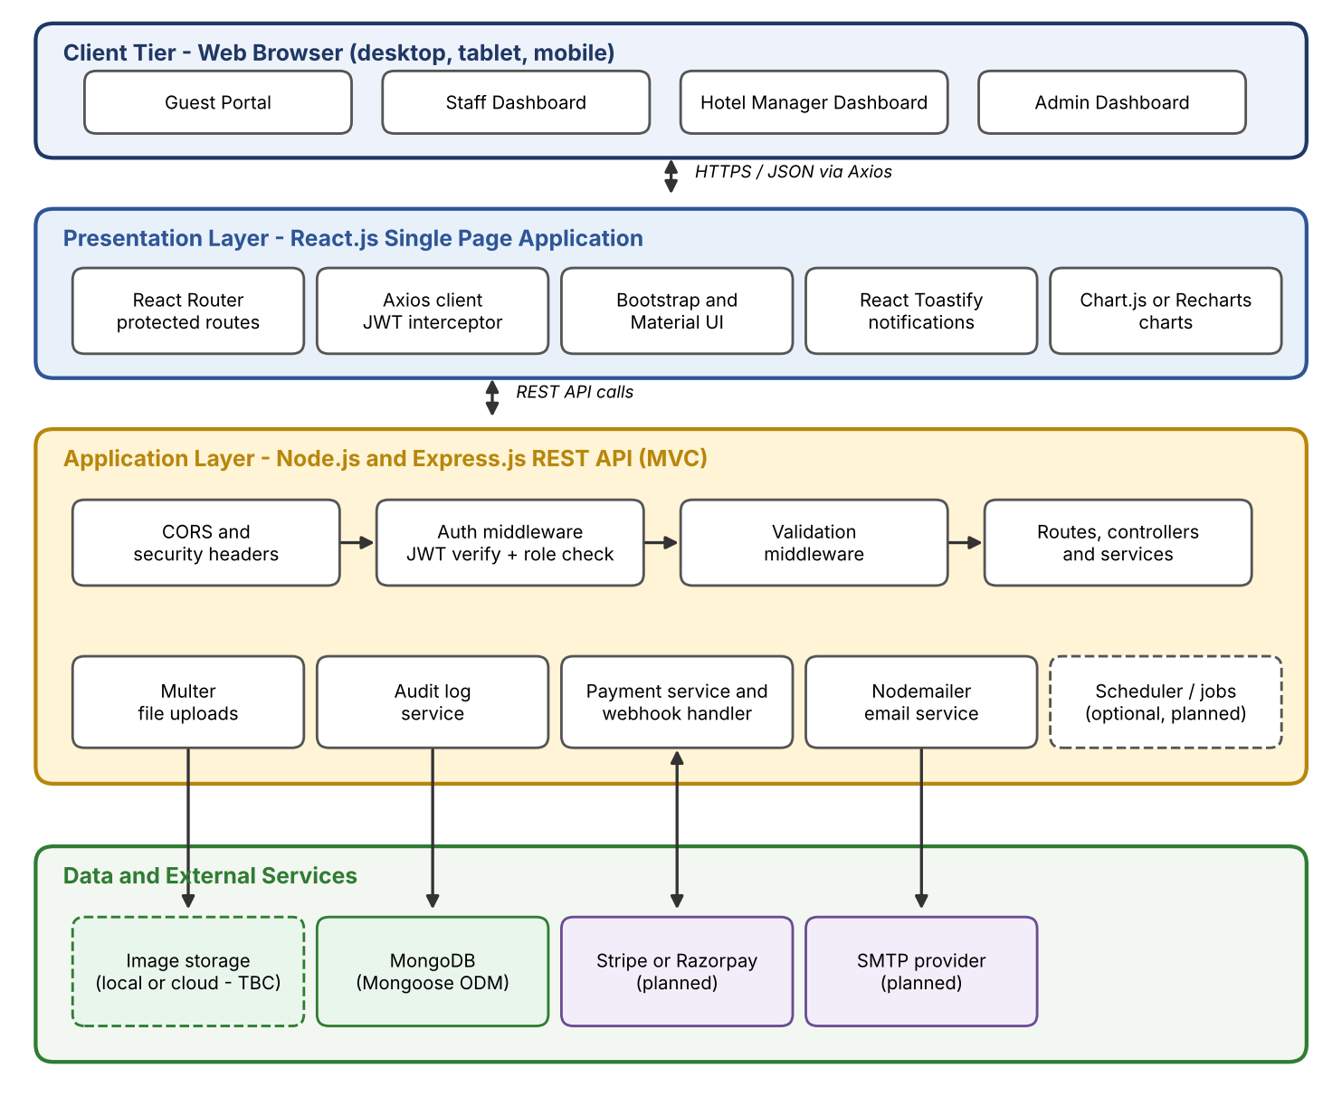
Figure 1: HotelPro solution architecture

3. Architecture Layers and Components
Table 1: Layers and components
Layer | Component | Responsibility | Status
Client | Browser (desktop, tablet, mobile) | Runs the React SPA; role-specific dashboards | Planned
Presentation | React Router, Axios, Bootstrap/MUI, React Toastify, Chart.js/Recharts | Routing, protected routes, API calls with JWT, UI, notifications, charts | Planned
Application | Express middleware (CORS, security headers, auth, validation) | Cross-cutting request handling | Planned
Application | Routes → Controllers → Services | Business rules: availability, pricing, booking state, payments, check-in/out | Planned
Application | Multer, Nodemailer, Payment service, Audit log service | Uploads, email, gateway integration, logging | Planned
Data | MongoDB via Mongoose | Persistent storage with schema validation and indexes | Planned
External | Stripe or Razorpay; SMTP provider | Payments/refunds; email delivery | Planned (selection TBC)

4. Request Lifecycle
- The user acts in the React UI; Axios sends an HTTPS request with the JWT in the Authorization header.
- Express applies CORS and security middleware.
- The authentication middleware verifies the JWT; the authorisation middleware checks the role.
- The validation middleware validates body, params and query.
- The controller calls a service that applies business rules and uses Mongoose models.
- The response is returned as JSON with a consistent success/error format; important actions are written to the audit log.

5. Key Flow – Booking and Payment
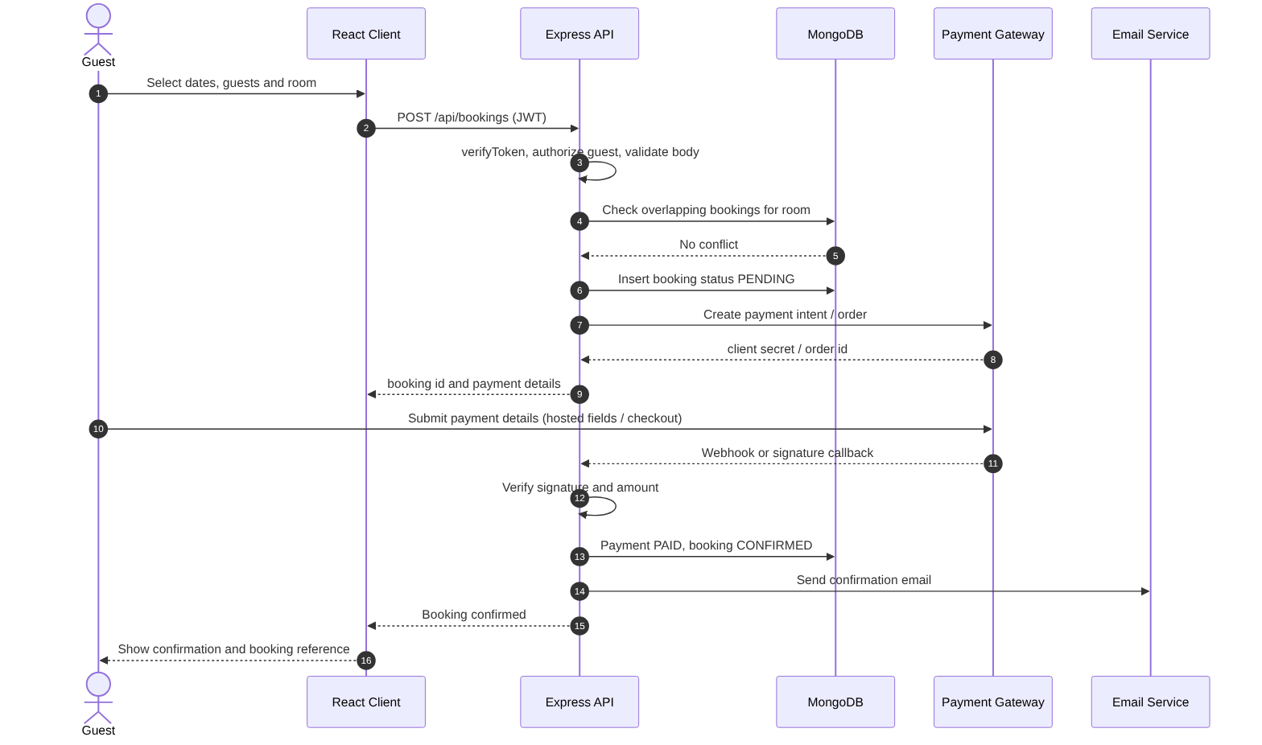
Figure 2: Booking and payment sequence

6. Data Architecture Summary
MongoDB collections are grouped as: identity (users, guests, staff), inventory (hotels, roomCategories, rooms, pricingRules), transactions (bookings, payments, checkInOuts), engagement (reviews, notifications, supportTickets), operations (services, serviceRequests, housekeepingTasks) and governance (reports, adminLogs). Full schemas, relationships and indexes are in the Database Design document.

7. API Overview
Table 2: API groups (detailed endpoints: Module Design document)
Group | Base Path | Primary Consumers
Authentication | /api/auth | All users
Rooms, categories, pricing | /api/rooms, /api/room-categories, /api/pricing-rules | Guest (read), Manager/Admin (write)
Bookings | /api/bookings | Guest, Staff, Manager, Admin
Payments | /api/payments | Guest, Admin, Gateway (webhook)
Stays (check-in/out) | /api/stays | Staff
Operations | /api/housekeeping, /api/service-requests, /api/support-tickets | Staff, Guest
Reviews and notifications | /api/reviews, /api/notifications | Guest, Admin
Administration and reports | /api/admin, /api/staff, /api/hotels | Admin, Manager

8. Security Architecture Summary
- HTTPS for all traffic; CORS restricted to the configured client URL.
- bcryptjs password hashing; JWT with expiry; role claims verified on each request.
- Server-side validation of all inputs; file-upload type and size limits.
- Payment verification by signature/webhook; card data never stored in HotelPro.
- Audit log for security and administrative actions.
Detailed controls: Security and Access Control Design document.

9. Design Decisions
Table 3: Design decisions
ID | Decision | Rationale | Alternatives
DD-1 | Single REST API for all roles with role-based middleware | Simpler than separate services for an academic-scale project | Microservices (rejected as over-engineering)
DD-2 | JWT-based stateless authentication | Scales horizontally; works well with SPA | Server sessions (needs shared store)
DD-3 | MongoDB with referenced documents | Flexible schema, natural fit with Node.js; references avoid large documents | Relational DB (not in stated stack)
DD-4 | Booking holds in PENDING state with expiry | Prevents room blocking by abandoned payments | Immediate confirmation without payment (rejected)
DD-5 | Hotel Management as a staff sub-role | Keeps role model to Guest/Staff/Admin as specified | Separate Manager role (to be confirmed)
DD-6 | Token storage strategy (httpOnly cookie vs memory/localStorage) | Security vs simplicity trade-off | To Be Confirmed

10. Deployment View
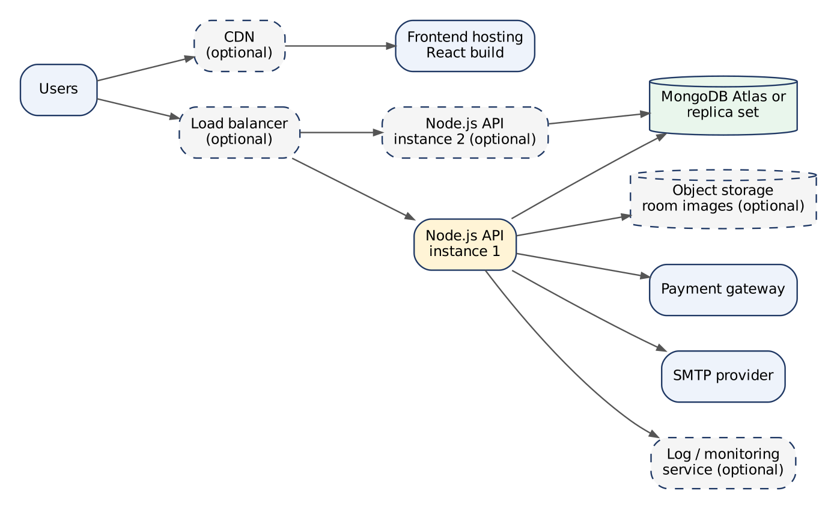
Figure 3: Planned deployment view (dashed items are optional)

References
- Express – Production Best Practices: Security – https://expressjs.com/en/advanced/best-practice-security.html
- OWASP Top 10 – https://owasp.org/www-project-top-ten/
- MongoDB Schema Design Patterns – https://www.mongodb.com/docs/manual/data-modeling/

